tables
GATHU MACHARIA
2024-06-03

Descriptive Statistics Between Hospitals in 2011 & 2012
Hospital Characteristics | 2011 |  |  | 2012 |  |  | P_Value
 | N | Mean | St. Dev | N | Mean | St. Dev
——————————– | :——————: | :—————-: | :—————-: | :——————: | :—————-: | :—————-: | :————–:
1. Hospital beds | 1505 | 376.6086 | 560.8998 | 1525 | 376.8000 | 579.8366 | 0.9926
2. Number of paid Employees | 1498 | 1,237.276 | 1,615.797 | 1515 | 1,491.121 | 1,961.637 | 0.0001
3. Number of non-paid Employees | 30 | 39.97300 | 72.58805 | 30 | 44.76976 | 81.29861 | 0.8104
4. Total hospital cost | 1505 | 216,873,322.00 | 304,570,722.0 | 327,490,734,909 | 1505 | 294,143,536.00 | 0.8451
5. Total hospital revenues | 1505 | 228,706,319.00 | 323,339,811.00 | 350,717,045,576 | 1505 | 321,273,114.00 | 0.9135
6. Available Medicare days | 1499 | 16,739.16 | 19,214.29 | 25,938,976.38 | 1484 | 19,765.74 | 0.6014
7. Available Medicaid days | 1484 | 5,301.199 | 9,207.699 | 8,054,865.540 | 1505 | 9,340.373 | 0.8479
8. Total Hospital Discharge | 1500 | 9,492.326 | 10,898.600 | 14,478,325.00 | 1517 | 10,994.170 | 0.8968
9. Medicare discharge | 1499 | 9,492.326 | 10,898.600 | 14,478,325.00 | 1516 | 10,994.170 | 0.0050
10. Medicaid discharge | 1481 | 1,130.727 | 1,757.158 | 1,677,082.00 | 1498 | 1,740.423 | 0.8615

The null hypothesis the means is not rejected since the pvalues of most characteristics are below 0.05 which is used as the significance level. The p-values indicate that the differences in means between the two years are not statistically significant for most characteristics, with the exception of the number of paid employees and Medicare discharges, where there were significant differences (p-value < 0.05). The mean number of paid employees increased from 1,237.276 in 2011 to 1,491.121 in 2012, suggesting an expansion in staffing levels. Similarly, the number of Medicare discharges also saw a significant change. However, for other metrics such as hospital beds, total hospital costs, revenues, available Medicare and Medicaid days, and total hospital discharges, the differences between 2011 and 2012 were not statistically significant, indicating similar performance levels across these years. Overall, while staffing levels and Medicare discharges showed notable improvements in 2012, the general performance metrics suggest stability rather than significant change between the two years.

Table 1: Comparison of Non-Teaching and Teaching Hospitals
Characteristics | Non-Teaching |  |  | Teaching |  |  | P_Value
 | N | Mean | Std. Dev | N | Mean | Std. Dev
Hospital beds | 627,528 | 299.68 | 536.77 | 513,888 | 549.03 | 605.07 | 0.0000000
Number of paid Employees | 1,812,690 | 869.81 | 1001.24 | 2,299,798 | 2475.56 | 2550.75 | 0.0000000
Number of non-paid Employees | 829.75 | 27.66 | 32.58 | 1,712.54 | 57.08 | 101.89 | 0.1408859
Interns and Residents | 12,791.13 | 41.53 | 96.47 | 77,060.71 | 124.90 | 179.45 | 0.0000000
Total hospital cost | 286,058,879,830 | 136,608,825 | 169,943,309 | 367,826,204,000 | 392,976,714 | 424,408,629 | 0.0000000
Total hospital revenues | 304,141,108,563 | 145,244,082 | 184,064,399 | 390,778,947,128 | 417,498,875 | 457,483,256 | 0.0000000
Net Benefit | 18,082,228,733 | 8,635,257 | 30,582,241 | 22,952,743,128 | 24,522,161 | 52,182,874 | 0.0000000
Available Medicare days | 24,251,999 | 11,626.08 | 13,979.94 | 26,778,980 | 28,825.60 | 24,287.36 | 0.0000000
Available Medicaid days | 6,285,448 | 3,057.12 | 5,538.33 | 9,636,397 | 10,372.87 | 13,102.66 | 0.0000000
Total Hospital Discharge | 13,249,370 | 6,345.48 | 7,654.59 | 15,467,444 | 16,649.56 | 13,564.48 | 0.0000000
Medicare discharge | 13,249,370 | 6,345.48 | 7,654.59 | 15,467,444 | 16,649.56 | 13,564.48 | 0.0000000
Medicaid discharge | 1,483,334 | 723.58 | 1,227.92 | 1,868,355 | 2,011.15 | 2,310.71 | 0.0000000

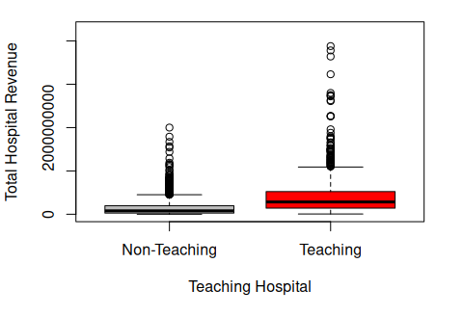

The boxpot shows how the hospital revenues are distributed across teaching and non teachin hospitals. It is clear that the average of teaching hospital revenues are higher than that of non teaching hospital. The question of whether the differene is statistically significant is answered by hypothesis testing using ttest. The distribution of Teaching hospital also have more outliers indicating extreme revenues generation compared to non teaching.
The null hypothess hat the means of the characteristics named in table in non-teaching hospital is similar with that of teaching hospitals is tested vs the alternative hypothesis that there means are not equal. The test statistics is standard t . The assumption that there are equal variances in the two groups can easily be tested so that we can know if there are equal variances in each characteristics being tested. The null hypothesis is rejected when the p-value is less than 0.05. Teaching hospitals outperform non-teaching hospitals in several key areas, as shown by statistically significant differences in their characteristics. Teaching hospitals have more beds, paid employees, interns, and residents, and they handle more Medicare and Medicaid discharges. Financially, teaching hospitals incur higher costs and generate more revenue, resulting in a significantly higher net benefit compared to non-teaching hospitals. This overall better performance of teaching hospitals is supported by significant p-values in these comparisons, indicating that the observed differences are not due to chance. It is important to note we cannot conclude that there is significant difference in the number of non paid employees since the pvalues are not less than 0.05.

Table 3: Hospital Characteristics by Level
Characteristics | Low |  |  | Moderate |  |  | High |  |  | Anova
 | N | Mean | Std. Dev | N | Mean | Std. Dev | N | Mean | Std. Dev
1. Hospital beds | 28,671 | 130.92 | 386.19 | 560,131 | 420.52 | 594.27 | 552,614 | 373.64 | 562.23 | 0.0116
2. Number of paid Employees | 109,477 | 499.89 | 813.26 | 2,078,828 | 1,570.11 | 1,954.92 | 1,924,184 | 1,308.97 | 1,722.45 | 0.082
3. Number of non-paid Employees | 0 | NaN | NaN | 896.96 | 35.88 | 30.50 | 1,645.33 | 47.01 | 97.12 | 0.5826
4. Interns and Residents | 843.08 | 38.32 | 45.60 | 47,462.96 | 112.21 | 176.11 | 41,545.80 | 86.55 | 149.90 | 0.1579
5. System Membership | 93 | 0.42 | 0.50 | 809 | 0.61 | 0.49 | 934 | 0.63 | 0.48 | 0.0000035
6. Total hospital cost | 16,137,471,936 | 73,687,086 | 121,326,585 | 340,353,512,222 | 255,520,655 | 341,985,822 | 297,394,099,672 | 201,077,823 | 267,368,743 | 0.3623
7. Total hospital revenues | 17,016,331,715 | 77,700,145 | 130,293,994 | 360,760,380,948 | 270,841,127 | 366,185,059 | 317,143,343,028 | 214,430,928 | 290,476,695 | 0.3126
8. Net Benefit | -17,016,331,715 | -69,674,028 | 130,293,994 | -360,760,380,948 | -240,200,183 | 366,185,059 | -317,143,343,028 | -187,724,717 | 290,476,695 | 0.000389
9. Available Medicare days | 1,177,610 | 5,377.21 | 9,993.89 | 25,134,520 | 18,983.78 | 20,297.62 | 24,718,850 | 16,792.70 | 19,219.18 | 0.0005
10. Available Medicaid days | 307,361.7 | 1,416.41 | 4,429.09 | 8,631,610.8 | 6,553.99 | 10,676.84 | 6,982,872.1 | 4,812.46 | 8,164.63 | 0.7673
11. Total Hospital Discharge | 571,116 | 2,607.84 | 5,065.39 | 14,719,872 | 11,100.96 | 11,741.30 | 13,425,826 | 9,120.81 | 10,397.48 | 0.0132
12. Medicare discharge | 233,878.5 | 1,067.94 | 1,753.82 | 5,006,851.5 | 3,781.61 | 3,652.70 | 5,056,918.8 | 3,435.41 | 3,623.24 | 0.00001
13. Medicaid discharge | 67,244 | 309.88 | 748.94 | 1,739,941 | 1,324.16 | 1,961.75 | 1,544,504 | 1,066.65 | 1,605.29 | 0.1208
14. Herfindahel index | 430 | 1.96 | 0.19 | 2,223 | 1.67 | 0.67 | 2,511 | 1.70 | 0.64 | 0

The null hypothesis that the mean of each characteristics is equal across all the three markets can be tested by Anova. The alternative hypothesis is that the mean is not equal in at least two of the markets. The test statistic is F and for large F value than the critical region we reject the null hypothesis. The assumptions of equal variance are always assumed in the basic anova test but one can use Welch Anova test when variance is not equal. In our study we reject the null hypothesis because the pvalues are less than 0.05 ad we conclude that there is enough evidence that the mean of both the characteristics is statistically significance in at least two of the markets. Post hoc analysis is carried out in anova to determine which combinations are statisically significance once the null hypothesis is rejected.
The p-value of Anova chi square shows that there is no significant difference between the hospital revenue across the three markets. The pvalues on other characteristics such as cost and interns paid show no significance difference.

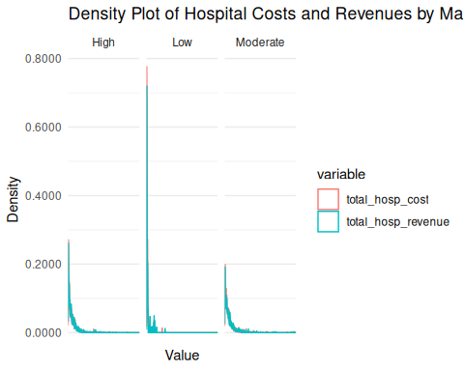

- Use the density curves and compare hospitals cost and revenues between three markets.
- What is the impact of being in high-competitive market on hospital revenues and cost? Do you think being in high-competitive market has positive impact on net hospital benefits? What about the number of Medicare and Medicaid discharge? Do you think hospitals in higher completive market more likely to accept more Medicare and Medicaid patients? What are the impact of other variables? Please discuss your findings in 1-2 paragraphs.
(Note: to answer to the last question, please compute the ratio-Medicare-discharge and ratio-Medicaid-discharge first and then run 2 ttest) high vs. moderate and high vs. low competitive market), please support your findings with box-plot).

Both the hospital revenues and hospital cost in the three markets are right skewed. This indicates that the majority of hospitals have relatively low revenues and costs, while a small number of hospitals have significantly higher revenues and costs. This skewness suggests that the bulk of hospital revenues in these markets come from a large number of smaller amounts, with a few larger hospitals generating disproportionately high revenues. The distribution of both cost and revenues in the hospitals from the three markets closely follow each other but in the lower end of the spectrum, costs exceed revenues. It is only in the higher end of the graph that hospitals generate large revenues in both markets.

 | diff | p adj
Low-High | 9340047 | 0.0028719
Moderate-High | -1967366 | 0.3786309
Moderate-Low | -11307414 | 0.0002266

Under null hypothesis that the net benefi is similar in all the markets is tested using anova one way test. The test statistics is F and for a pvalue less than 0.05 the null hypothesis is rejected. The observed p value in table 3 is less tha 0.05 leading to rejectio of null hypothesis. We conclude that there are not the same net benefits across the three markets. A post hoc analysis is important and it is carried out. Th results of post hoc analysis in table 4 shows there is a diifference in low high and in moderate -low. There is no significance difference in moderate and high. These will lead to a conclusion that being in a moderate market and higher market will led to a higher benefits as compared to being in a lower competitive market. There is no signifant difference in being in moderate vs igh competetive market.

Characteristics | Anova (p-value) p adj
Medicaid ratio | 0.102 0
Medicare ratio | 0 0

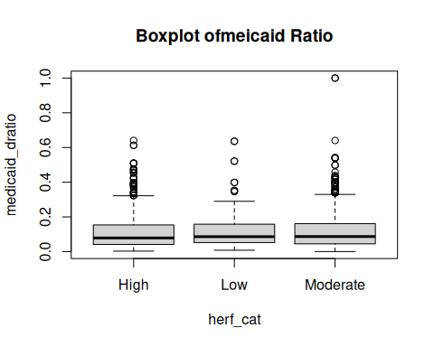
Anova is similar to tests only that it analyses the variance of means. Carrying th anova test for medicaid ratio ; the null hypothesis that the eans are equal across all the markets vs that the means are not equal ina atleast two of the markets is tested. The test statistics is F and the null hypothesis is rejected if the p-value is less than 0.05. In this study the null hypothesis is rejected that the means of medicaid ratio are equal for this group. The conclusion is that hospitals in higher completive market are more likely to accept more medicaid after comparing the values of the means. We also do an Anova test for the medicare ratio and find the same conclusions that hospitals in higher completive market are more likely to accept more Medicare. The post hoc analysis for the test shows that they are significantly different from each other.

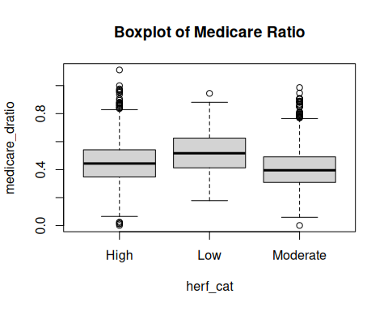

Exercise 4

 | Model 1a
Hospital Characteristics | Coef. | St. Err | Pr(>|t|)
Hospital beds | -73150 | 3220 | 0.429
Ownership
For Profit | 2409879 | 1837706 | <2e-16 ***
Non-for profit | 3420199 | 2189969 | 0.118
Other | 2224995 | 1661067 | 0.181
N | 2998
R-Squared | 0,1463
A linear model on net benefits on ownership is considered. The parameters shows that a unit increase in hospital beds leads to decrease of hospital net benefit by 73158. Ownership is in four categories and one is used as a reference category. A unit increase in for profit ownership leads to net benefit increase by 2409879 with reference to those who don’t have ownership. Other categories shows a similar relationship with respective values shown in table 5.

 | Model 2
Hospital Characteristics | Coef. | St. Err | Pr(>|t|)
Hospital beds | -71276 | 3251 | < 2e-16
Ownership
For Profit | 2172134 | 1834796 | 0.236564
Non-for profit | 3521355 | 2185368 | 0.107212
Other | 2000968 | 1658522 | 0.227728
Membership
System Membership | -5145510 | 1368152 | 0.000173
N | 29997
R-Squared | 0.1514

System membership has two categories those who are members and those are not. A linear regression of those who are members is fitted. The results shows that a unit increase in those who are memmbers decreases the net benefit by 5145510 compared to those who are not members.

 | Model 3
Hospital Characteristics | Coef. | St. Err | Pr(>|t|)
Hospital beds | -71355 | 3661 | 2e-16
Ownership
For Profit | 2156294 | 1859286 | 0.246247
Non-for profit | 3545406 | 2209990 | 0.108762
Other | 1998577 | 1719083 | 0.245092
Membership
System Membership | -5247414 | 1392923 | 0.000168
Socio-Economic Characteristics
Medicare discharge ratio | 305422 | 5298689 | 0.954038
Medicaid discharge ratio | -300477 | 7626550 | 0.968575
N | 2970
R-Squared | 0.1511

A medicare ratio and medicaid ratio is calculated. A linear model is also fitted and parameters are inferenced. The parameters show that a unit increase in Medicare discharge ratio leads to net benefit increase by 305422 while that for Medicaid discharge ratio leads to decrease by 300477.

There are several policies that may need to be adopted by hospitals; Hospitals may need not to add the number of beds. The model shows that a unit increase in beds leads to to a loss or reduced net benefit. This policy will help the hospitals stop loosing money. They also need to reduce the number of system members or stop any more member. An increase in system membership leads to reduced net benefits as the model shows. The hospitals really need to increase Others in the ownership. The model shows that other ownership immensely leads to an increase in net benefits compared to all other ownership.
Inferencing linear regresion parameters is very useful for the analysis of hospital performance. Although the model may help us in giving key inferences it is important that the model adequacy it is tested. The residuals must be normally distributed and the explanatory variables must be normally distributed for the R-squared to have a better percentage. The R-squared in the model is at most 0.152, this shows a low performance of the model. On investigations, the variables are poorly correlated with the response variable which is needed in Linear regression.

References

Adichie, J. N. [1967], “Estimates of regression parameters based on rank tests,” Ann. Math. Stat., 38, 894–904.
Aitkin, M. A. [1974], “Simultaneous inference and the choice of variable subsets,” Technometrics 16, 221–227.
Akaike, H. [1973], “Information theory and an extension of the maximum likelihood principle,” in B. N. Petrov and F. Csaki (editors), Second International Symposium on Information Theory. Budapest: Academiai Kiado.
Allen, D. M. [1971], “Mean square error of prediction as a criterion for selecting variables,” Technometrics, 13, 469–475.
Allen, D. M. [1974], “The relationship between variable selection and data augmentation and a method for prediction,” Technometrics, 16, 125–127.
Andrews, D. F. [1971], “Significance tests based on residuals,” Biometrika, 58, 139–148.
Andrews, D. F. [1974], “A robust method for multiple linear regression,” Technometrics, 16, 523–531.
Andrews, D. F. [1979], “The robustness of residual displays,” in R. L. Launer and G. N. Wilkinson (Eds.), Robustness in Statistics, Academic Press, New York, pp. 19–32.

